Discrete NN with 2 Gradients

Epsilon 0.05 Robust


Epsilon 0.05 Not Robust (from 7 it becomes 4)

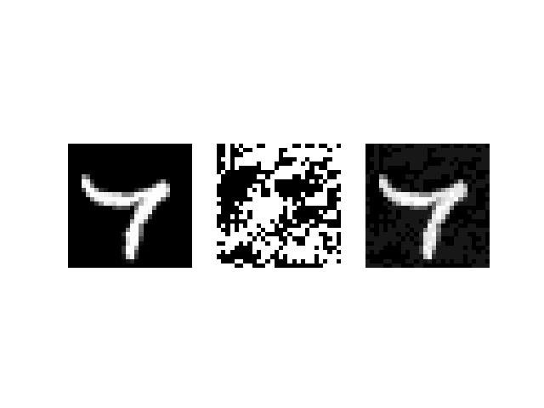

Epsilon 0.07 Robust


Epsilon 0.07 Not Robust (from 4 it becomes 9)

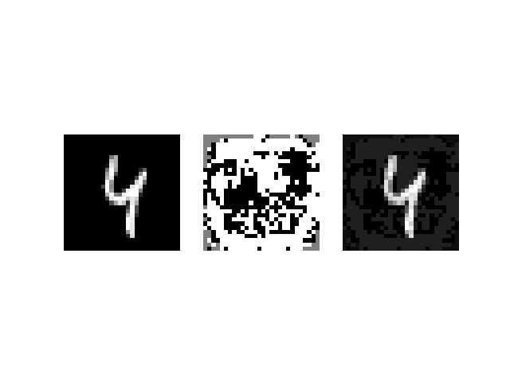

Epsilon 0.1 Robust

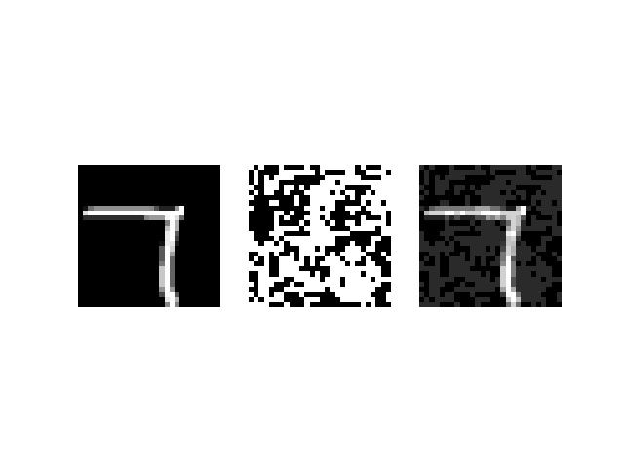
Epsilon 0.1 Not Robust (from 9 it becomes 5)



Epsilon 0.3 Not Robust (from 1 it becomes 8)


Epsilon 0.5 Not Robust (from 9 it becomes 4)



